**Experiment 9-**

**-Bahnijit Barman**

**1.**

**Source Code-**

**public** **class** ThreadOne **extends** Thread{

**public** **void** run() {

System.***out***.println("Threads are on move....");

}

}

**public** **class** Imple **implements** Runnable{

**public** **void** run() {

System.***out***.println("Threads are upto world invasion");

}

}

**public** **class** OneMain {

**public** **static** **void** main(String[] args) {

// **TODO** Auto-generated method stub

ThreadOne th1= **new** ThreadOne();

th1.start();

Imple m2= **new** Imple();

Thread t1= **new** Thread(m2);

t1.start();

}

}

**Output-**

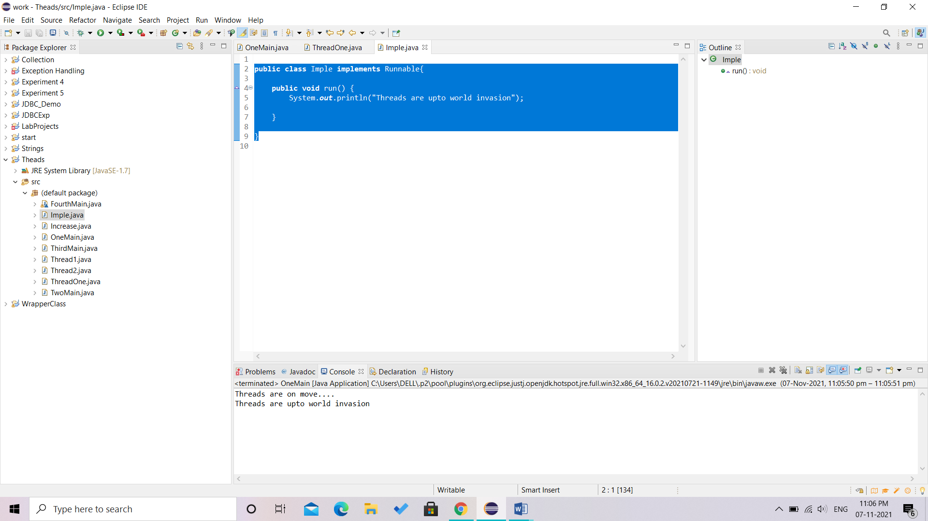

**2.**

**Source Code-**

**public** **class** Thread1 **extends** Thread{

**public** **void** run() {

// **TODO** Auto-generated method stub public void run() {

**for** (**int** i = 1; i < 11; i++) {

**if** (i % 2 == 0) {

System.***out***.println("even thread " + i);

}

}

}

}

**public** **class** Thread2 **extends** Thread{

**public** **void** run() {

**for** (**int** i = 1; i <11; i++) {

**if** (i % 2 != 0) {

System.***out***.println("odd thread " + i);

}

}

}

}

**public** **class** TwoMain{

**public** **static** **void** main(String[] args) {

// **TODO** Auto-generated method stub

//even numbers

Thread1 th1 = **new** Thread1();

th1.start();

//odd numbers

Thread2 th2 = **new** Thread2();

th2.start();

}

}

**Output-**

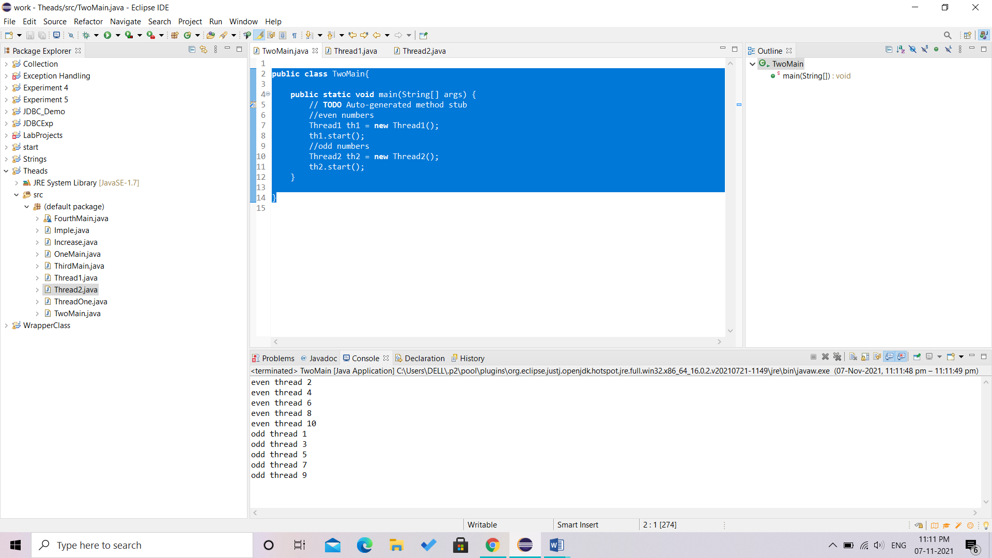

**3.**

**Source Code-**

**public** **class** Increase **implements** Runnable {

**int** n=1;

**public** **synchronized** **void** run() {

System.***out***.println(n++);

}

**public** **void** showOutput(){

System.***out***.println(n++);

}

}

**public** **class** ThirdMain

{

**static** Thread[] *threads* = **new** Thread[10];

**public** **static** **void** main(String[] args)

{

Increase c = **new** Increase();

**for**(**int** i=0;i<10;i++)

{

*threads*[i] = **new** Thread(c);

*threads*[i].start();

}

}

}

**Output-**

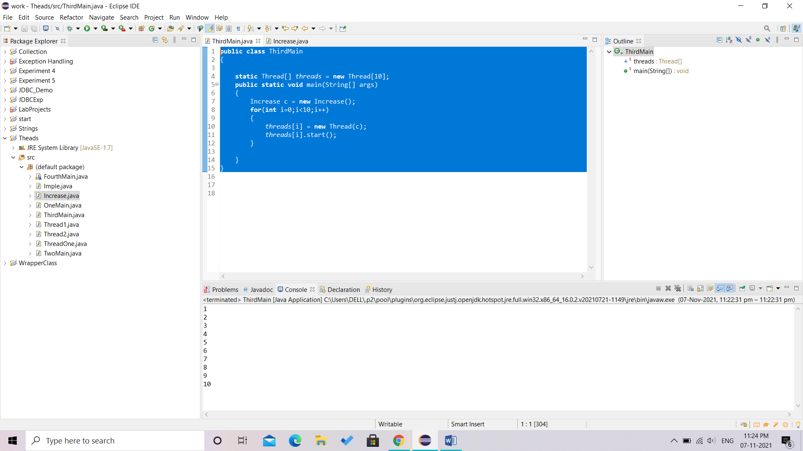

**4.**

**Source Code-**

**import** java.lang.*;

// Main class

**class** FourthMain **extends** Thread {

// Method 1

// run() method for the thread that is called

// as soon as start() is invoked for thread in main()

**public** **void** run()

{

// Print statement

System.***out***.println("Inside run method");

}

// Main driver method

**public** **static** **void** main(String[] args)

{

// Creating random threads

// with the help of above class

FourthMain t1 = **new** FourthMain();

FourthMain t2 = **new** FourthMain();

FourthMain t3 = **new** FourthMain();

// Thread 1

// Display the priority of above thread

// using getPriority() method

System.***out***.println("t1 thread priority : "

+ t1.getPriority());

// Thread 1

// Display the priority of above thread

System.***out***.println("t2 thread priority : "

+ t2.getPriority());

// Thread 3

System.***out***.println("t3 thread priority : "

+ t3.getPriority());

t1.setPriority(2);

t2.setPriority(5);

t3.setPriority(8);

System.***out***.println("t1 thread priority : "

+ t1.getPriority());

System.***out***.println("t2 thread priority : "

+ t2.getPriority());

System.***out***.println("Thread name : "

+ Thread.*currentThread*().getName());

}

}

**Output-**

